Area of triangle:
55
?
66°
13cm
e.g. Area$={[(\frac{66}{360})×π×}$13]² ─ [ ½ $×$13 $×$ 13 $×$ cos66]
=97.3370123837cm²─34.3692463399cm²
=62.9677660438cm²
=62.97 cm²

Area of Segment $={(\frac{θ}{360}×}$ πr²)─ ( ½ x r x r x cosθ)

Area of segment= Area of sector – Area of triangle 2r²
Area of Segment:
e.g. Area= ½ x 15 x 15 x cos55
=64.5273490895

15cm
15cm
Area of triangle: ½ x b x c x cosA

Length of Arc:
e.g. π6²
=113.097335529cm²
=$\frac{80}{360}×$ 113.097…
=25.1327412287cm²
=25.13cm²
6cm
80
e.g. 2π10
=31.41…cm
=$\frac{60}{360}×$ 31.41..
=5.2359877559cm
=5.23cm
10cm
Area of Sector= $={\frac{θ}{360}×Area of the Circle}$
Area of Sector:
C= 40cm
60
Length= $={\frac{θ}{360}×Circumference of circle}$

Circles:
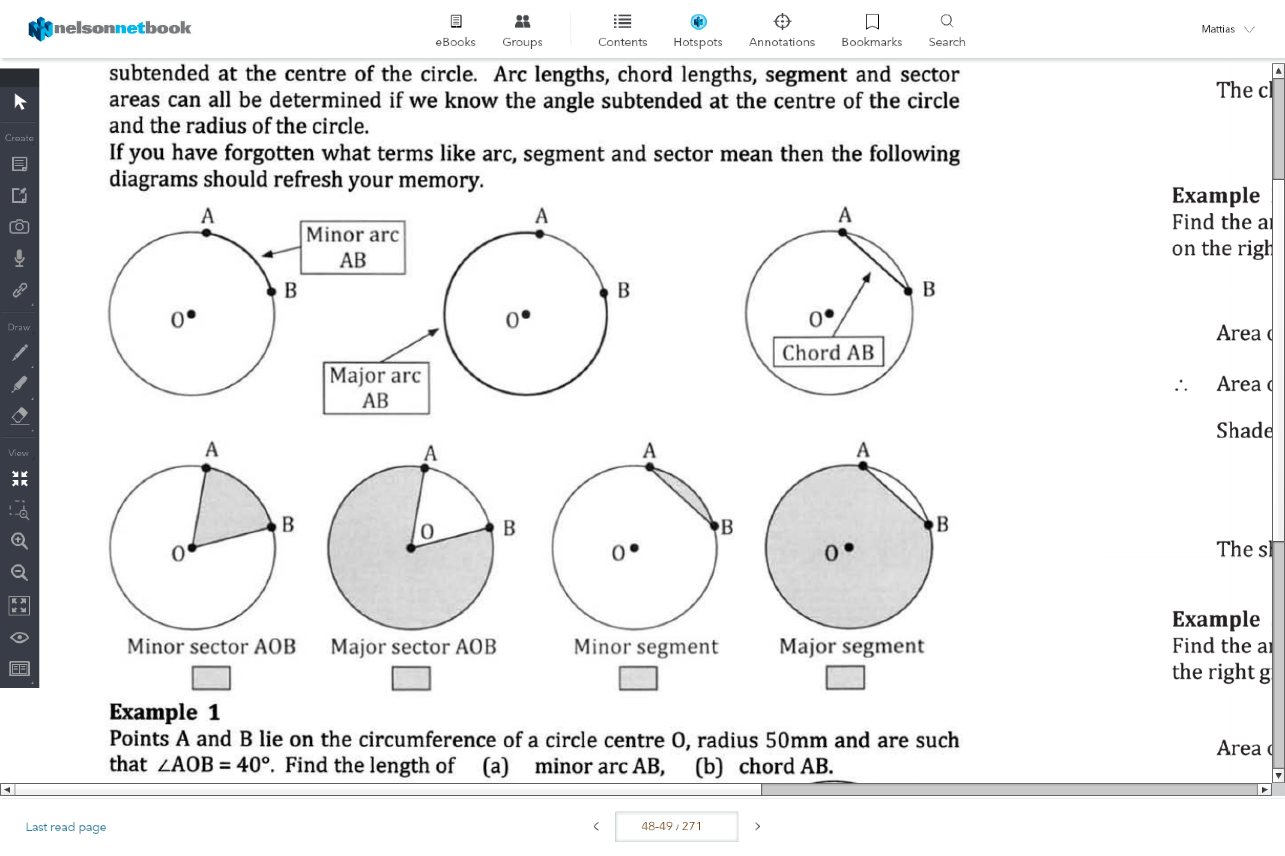
Area:
Area of a circle: πr²
e.g. π30²
=2827.433…cm²
30cm
12cm
e.g. 2π12
=75.398…cm
Circumference= 2πr
Circumference:

